ASD

Communication and interaction - Ability to communicate and interact effectively?

Executive function needs: - This simply refers to a set of cognitive processes that help us connect past experience with present action. These processes enable us to plan, focus attention, remember instructions, and juggle multiple tasks successfully.

Potential challenges
- Focus attention
- Plan and organise
- Remember instructions
- Juggle multiple tasks successfully
- Shift attention in response to different demands
- Ability to apply different rules in different context

Theory Of Mind

Potential challenges
- Ability to mind read – put self in other people’s shoes – affects social interaction (focus on own interest)
- Sharing attention
- Ability to predict other people’s behaviour, read other’s intentions,
- Importance of communicating needs as expects others to already know – difficulty considering what others know or can be expected to know.
- Inability to understand and react to a listener’s level of interest in what they are trying to communicate, inability to predict what others might think of their actions, and ability to differentiate fact from fiction.

Central Coherence
- This simply refers to the ability to integrate information at different levels to create meaning and respond appropriately.

Potential Challenges
- Inability to give account of events, describe a sequence, or give explanation.
- Reciprocity?

Cognition and learning
- Difficulty with ability to think flexibly and shift approaches means that pupil struggles with a range of executive function skills required to effectively control their cognitive process, to enable effective and independent problem solving and learning. For example:
- Struggles to cope with unexpected changes in routines, which can be a significant source of anxiety that affects capacity to maximise learning opportunities (clear routines with changes communicated).
- Sustain focus and attention in lessons, particularly if topic is not of interest. This has implications for ability to independently follow complex instructions, or complete tasks/activities requiring multi-step instructions, as they are likely to be missing key input from the teacher.
- Inflexibility and rigidity in perception has implications for listening and reading comprehension, as they are likely to struggle to independently draw inferences and make deductions from information that they read or listens to.
- Struggles to interpret information in more than one way or change approaches and strategies when needed. They will continue to require high levels of scaffolded support with their comprehension, as this requires them to go back and forth between major themes and supporting details to sift and sort information while reading.

Social emotional and mental health
- High levels of stress and anxiety associated with difficulties accessing the curriculum.
- Mask difficulties in school, but frustrations tend to manifest as meltdowns at home.
- Lacks the skills to initiate and sustain relationships. Potential impact on ability to develop any meaning friendships with peers.
- A key concern is in the high levels of anxiety, will progressively increase as they progress through school, with the learning and social aspects become increasingly more abstract.

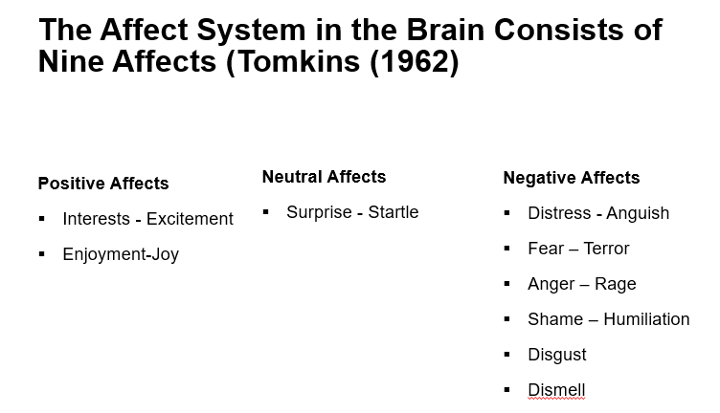

- Fear – terror – Their senses picking something too big, too loud or too fast.
- Distress – anguish - Response triggered when too much has been happening for too long.

- Enjoyment-joy - is the affect triggered when that too much finally stops happening
- When their senses encounter a novel stimulus that is just right - interest- excitement is triggered.

- Most of the experiences of interest and joy that get impeded have to do with social joining. So, we think of shame as an interpersonal/interactional affect.
- Once positive affect is impeded, affect shame focuses attention on the impediment.
- Now, the thing is what we see in the moment of shame is something in us that isn’t perfect – scripted emotions.

We are innately programmed to:
- Maximise positive affect
- Minimise negative affect
- Minimise the inhibition of affect

Pupil drawing on scripts built up over time to help minimise negative affects… What scripts do you see them drawing on?

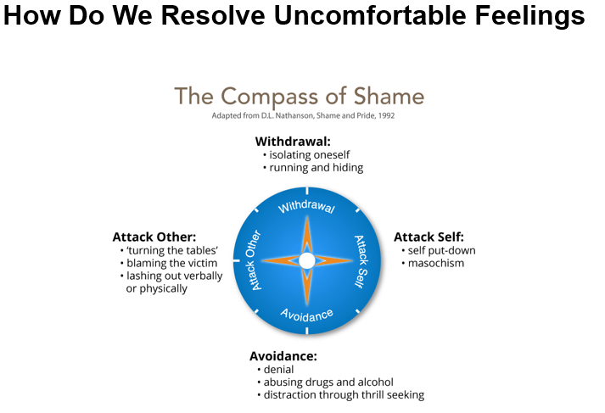

- Withdraw - Switch off from learning and not attend lessons.
- Attack self - Put themselves down, assume they are dumb.
- Avoid - Be the class clown, focus on other aspect of their lives, take risks, use drugs etc.
- Attack other - Put others down, belittle value of work, diminish someone, bully others.

What might be happening in a complex learning environment…

Complex learning

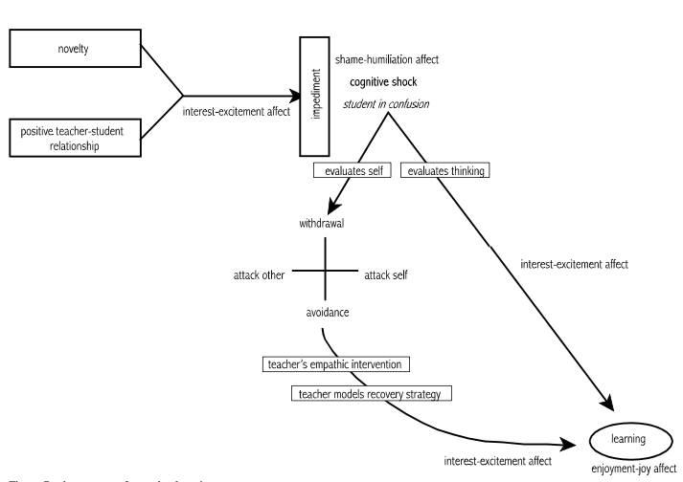

Things to consider - Related to whether they have developed a fixed ability or growth mindset

These determine outcome: achieve less than full potential or reach ever higher levels of achievement.
- Desire/motivation for learning:
- is learning about looking smart in every situation, proving themselves and never failing, or
- is it about taking risk, learning, and thriving on challenges?
- How do they evaluate situations?
- Do they think of challenges in terms of success or failure, looking smart or dumb, or
- Do they see tasks as opportunity to grow and/or them do better in future.
- How do they deal with setbacks?
- Do they attribute setbacks as them being a failure (self-identity) – shame-like, I can’t do this (attack self), or
- to their behaviour - I failed (behaviour – guilt-like), I need to try harder, do things differently.
- How do they perceive change?
- avoids challenges, get defensive, or give up easily (compass of shame), or
- embrace challenges, persist in the face of setbacks (employs interest)
- How do they perceive effort?
- thinks effort indicates low intelligence, or
- that growth and learning require effort.
- How do they take criticism?
- ignore constructive criticism, it can’t help, or,
- learn from it, how can I improve?
- How do they perceive success of others?
- feels threatened by others success (shame affect), or
- finds lessons and inspiration in others success.

What to do
- Through empathic intervention, recovery strategies can be modelled to trigger interest and excitement where shame was previously triggered. Focus on the behaviour is more adaptive (guilt like response). It triggers interest-excitement affect that leads to understanding and learning that produce enjoyment-joy from success.
- Needs supportive teacher, praise his efforts, and gently guide his work. High expectations and belief that he can do the work. Revise his script for failure.

Promote a growth mindset
- Establish high expectations (not just high standards).
- Create a risk-tolerant learning zone.
- Give feedback that focuses on process – things that he can control.
- Focus on how tasks/activities are framed and how feedback is provided.
Framing tasks
- Example of communicating learning goals: we are in the learning zone today; mistakes are our friends!
Communicating high expectations
- Example of communicating high expectations: As you learn this, mistakes are expected. Your mistakes help me to support you. Let’s make mistakes together!
Giving feedback:
- example of when he struggles despite strong effort: I admire your persistence and I appreciate your hard work. It will pay off!
- Example of when he struggles and needs help with strategies: Let’s do one together…
- Example of when he is making progress: I see you using your strategies/tools/notes etc. keep it up!
- Example of when he succeeds with strong effort: I am very proud of you for not giving up and look what you have to show for it!

Other suggestions
- Empathic intervention – can’t happen without trust and mutual respect (unconditional positive regard)
- Promote a growth mindset
- Establish high expectations (not just high standards).
- Create a risk-tolerant learning zone
- Give feedback that focuses on process – things that he can control
- Focus on how tasks/activities are framed and how feedback is provided

- Identify strength and find opportunities to highlight
- Empower, give role to help confidence
- Comprehension – careful of how instruction is delivered.
- Explain how diagnosis affect him so he knows it is not about a lack of ability
- Careful of how feedback is presented
- Work closely with therapist
- Key person he can check in with – relationship is key

